Non-Linear Filters (Order Static)
code:
import cv2
import numpy as np
import matplotlib.pyplot as plt
image = cv2.imread('bal.jpg')
median_filtered = cv2.medianBlur(image, 15)
bilateral_filtered = cv2.bilateralFilter(image, 15, 75, 75)
kernel = np.ones((15, 15), np.uint8)
erosion_filtered = cv2.erode(image, kernel, iterations=1)
dilation_filtered = cv2.dilate(image, kernel, iterations=1)
plt.figure(figsize=(15, 10))
plt.subplot(2, 3, 1)
plt.imshow(cv2.cvtColor(image, cv2.COLOR_BGR2RGB))
plt.title("Original Image")
plt.axis('off')
plt.subplot(2, 3, 2)
plt.imshow(cv2.cvtColor(median_filtered, cv2.COLOR_BGR2RGB))
plt.title("Median Filter")
plt.axis('off')
plt.subplot(2, 3, 3)
plt.imshow(cv2.cvtColor(bilateral_filtered, cv2.COLOR_BGR2RGB))
plt.title("Bilateral Filter")
plt.axis('off')
plt.subplot(2, 3, 4)
plt.imshow(cv2.cvtColor(erosion_filtered, cv2.COLOR_BGR2RGB))
plt.title("Erosion Filter")
plt.axis('off')

plt.subplot(2, 3, 5)
plt.imshow(cv2.cvtColor(dilation_filtered, cv2.COLOR_BGR2RGB))
plt.title("Dilation Filter")
plt.axis('off')
plt.tight_layout()
plt.show()

Explanation of Non-Linear Filters:
- Median Filter (cv2.medianBlur): It replaces each pixel with the median value of the pixels in its neighborhood. This is commonly used for noise reduction, especially "salt-and-pepper" noise.
- Bilateral Filter (cv2.bilateralFilter): It performs edge-preserving smoothing by considering both spatial proximity and pixel intensity differences. This filter is useful for noise reduction while preserving edges in images.
- Erosion (cv2.erode): This morphological operation erodes the boundaries of foreground objects, making them smaller. It is useful in removing small-scale noise.
- Dilation (cv2.dilate): This operation increases the size of the foreground objects by adding pixels to the boundary. It is the opposite of erosion and can be used for object enhancement.

Output:

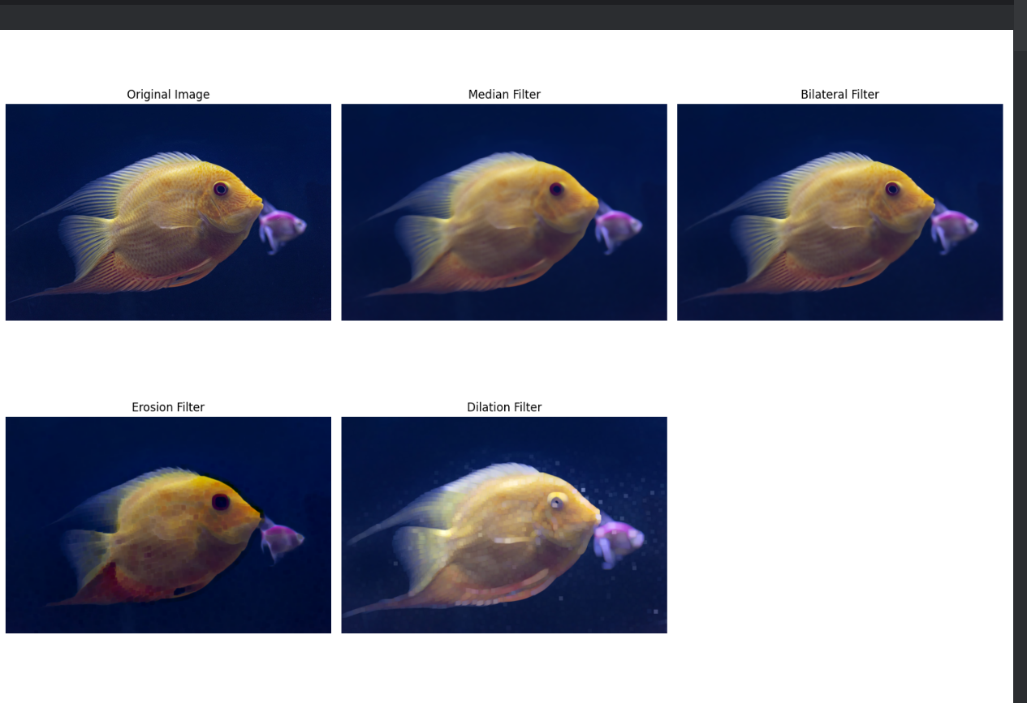

Report:
- Median Filter: This filter is effective in reducing noise, especially salt-and-pepper noise, while maintaining edge details.
- Bilateral Filter: While effective in reducing noise, it tends to preserve edges better than linear filters like Gaussian blur.
- Erosion and Dilation: These morphological operations are useful for object-based filtering, where we may want to shrink or expand objects in the image.

